Session 7
Aim
To study preemptive scheduling, Round Robin, priority scheduling, context switching , race conditions and deadlock.
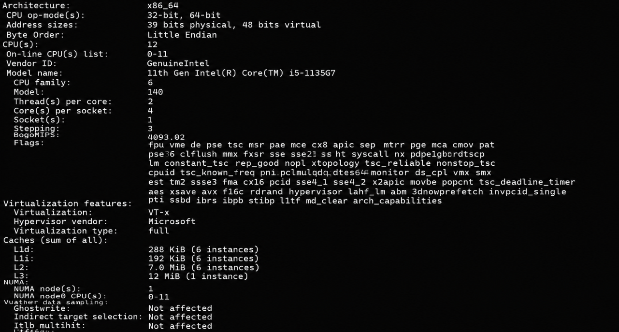
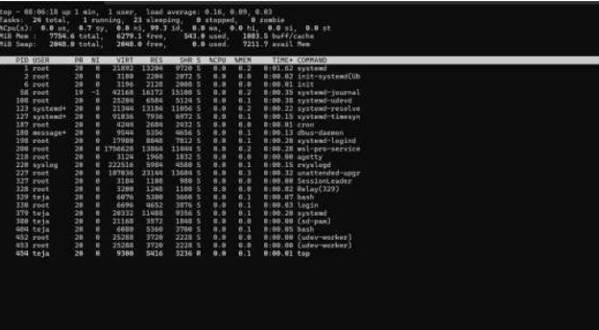
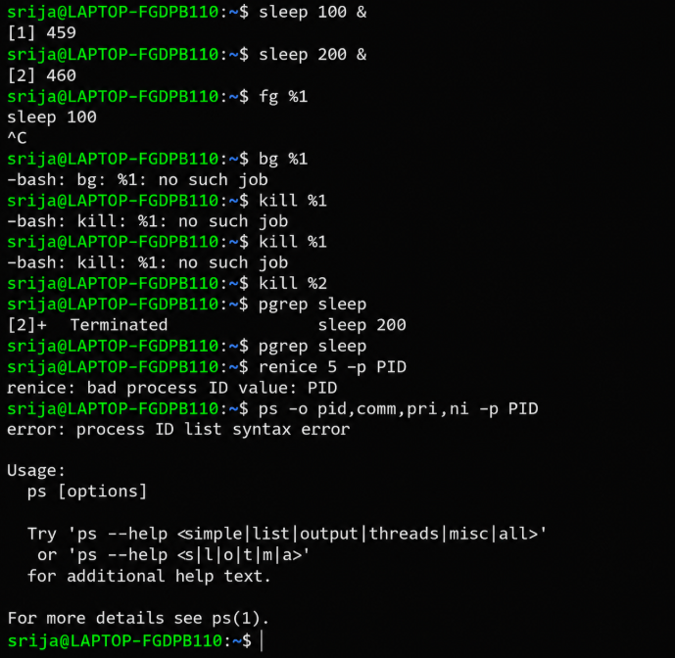
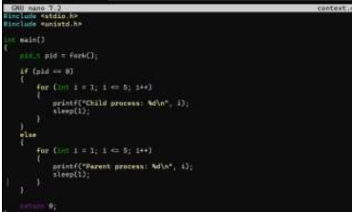
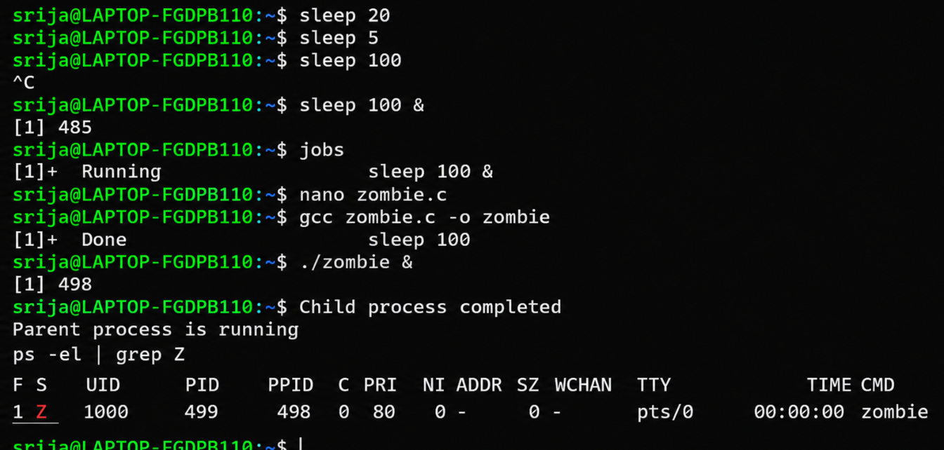
Short theory
The parent and child processes execute alternately.The operating system saves one process state and loads another process state. This operation is called context switching.
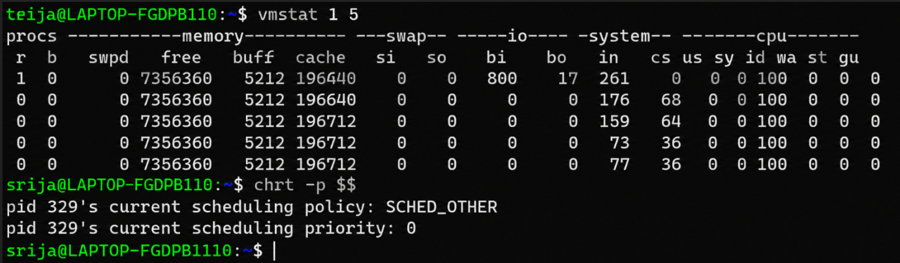
In this session, we studied preemptive scheduling and context switching.Round Robin gives each process a fixed time quantum.Priority scheduling selects the process with the highest priority. We also studied race conditions , critical sectons, deadlock, starvation and aging.A deadlock occurs when processes wait permanently for resources held by one another.Aging prevents starvation by gradually increasing the priority of a waiting process.

